BRIDGE BUILDING CONTEST RULES
1. The bridge must be built according to the bridge building code, using only materials supplied by the l. Saw Lumber Company.
2. The bridge will be judged for the quality of the building plans and the strength of the bridge.
A. Judging of the building plans will consider neatness of the finished bridge, cost of the bridge, and how well the finished bridge matches its plans.
B. The bridge will be tested for strength by placing a bar across the middle of the bridge and hanging weights from the bar.
1. The teacher will suspend weights from the bridge according to the project director's wishes.
2. The last weight that the bridge holds for 30 Seconds without touching the cardboard in any spot (except at the bridge foundation) is the weight recorded for the strength of the bridge.

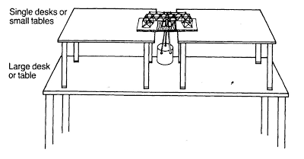

Bridge Building Code
1. Build the bridge on a piece of cardboard 15 cm by 35 cm (figure 1).
2. Draw a river, 15 cm wide, in the middle of the cardboard (figure1).
3. Draw one 5-cm square at each end of the cardboard, 2.5 cm from the river and 2.5 cm from the edge (figure2).
4. Draw and cut a 4-cm square exactly in the center of the card board, in the river (figure2).

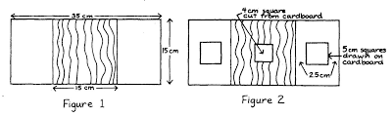
5. If you choose, plans can be drawn of the bridge to show four views: the view from one end, the side view, the road bed, and the top view. The plans must be readable, clear, and may not be changed once construction has begun. THESE PLANS WILL NOT BE JUDGED.
6. When building the bridge, only apply glue sparingly to join the toothpicks.
7. The bridge must at all times touch only the cardboard inside the drawn squares. Toothpicks may be glued into holes punched inside in the cardboard the squares.
8. The bridge must be more than 5cm high. This distance is measured from the cardboard to where the deck of the bridge would be. The tag board boat,5 cm tall, must be able to travel the length of the river.
9. The bridge must be at least 4 cm wide. The tagboard truck, 3.5cm wide, must be able to travel the length of the road, if the bridge had a deck.

